Ideation Phase
Define the Problem Statements

Date | 31 January 2026
Team ID | LTVIP2026TMIDS73502
Project Name | Rising Waters: A Machine Learning Approach to Flood Prediction
Maximum Marks | 2 Marks

Problem Statement (PS-1)
I am (Customer)
A resident living in a flood-prone rural/urban area.
I’m trying to
Stay safe and protect my family and property from sudden floods.
But
I do not receive accurate or early warnings about upcoming floods.
Because
Traditional warning systems rely on delayed reports and do not use real-time predictive data.
Which makes me feel
Anxious, unsafe, and unprepared during heavy rainfall seasons.
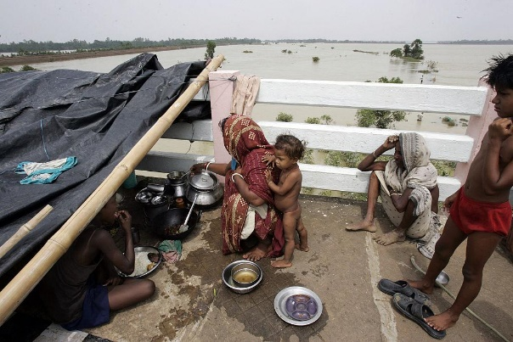

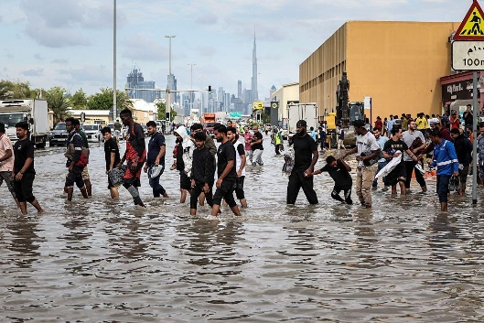
Problem Statement (PS-2)
I am (Customer)
A government disaster management officer.
I’m trying to
Provide early alerts and reduce damage caused by floods.
But
I lack an accurate predictive system that analyzes real-time environmental data.
Because
Existing systems are reactive and not powered by advanced machine learning models.
Which makes me feel
Helpless and under pressure during emergency situations.
